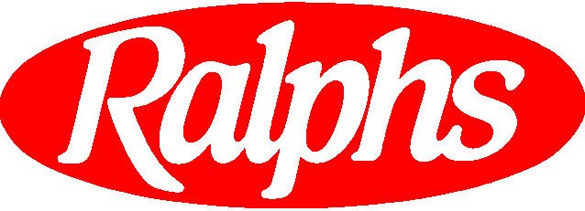March 23, 2001

Mark Ahlness
Earth Day Groceries Project

Mark:

Ralphs Supermarkets enthusiastically supports the Earth Day Groceries Project through the Paper Bag Council of the American Forest & Paper Association and our paper bag supplier, Willamette Industries, Inc.

Your idea of encouraging elementary and middle school students to decorate paper grocery bags with environmental themes and messages is an excellent way to help our youth learn about protecting the environment. In addition, it brings the community together for a good cause – encouraging teachers, families and local businesses to work together toward a positive goal.

Ralphs is proud to endorse this project for the third year. We are committed to supplying our recyclable handled paper grocery bags to local schools throughout California. In fact, our nearly 350 store directors are sending letters and special handled paper bags to elementary and middle schools in their neighborhoods. We are inviting teachers to come into their local Ralphs supermarket to pick up an Earth Day Groceries Project poster and all of the handled paper bags they need for their students to decorate with messages about the environment. We look forward to displaying the decorated bags in our stores in celebration of Earth Day. This is a great project for our children, our customers, our community and the environment.

The recyclable handled paper bags Ralphs uses in its stores are in keeping with our company’s ongoing commitment to the community and our environment. The handled paper bags Ralphs uses are made from a minimum of 50% post-consumer recycled fiber and are 100% recyclable and completely compostable. They are ideal for the Earth Day Groceries Project.

Once again, congratulations on a very worthwhile program. We wish you and the thousands of Earth Day Groceries Project participants much success.

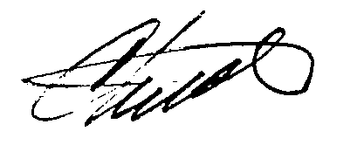
Sincerely,

Chuck Ackerman
Senior Vice President, Sales & Advertising
Ralphs Supermarkets

